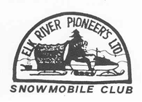
2025-2026 Membership Dues: $25.00
( ) New Member or ( ) Renewal
Club email address: elkriverpioneers@gmail.com

Name:______________________________________________________________
Spouse Name: _______________________________________________________
Address:____________________________________________________________
City:_____________________ State:________________ Zip Code_____________
Home Phone:________________________________________________________
Cell Phone:______________________Spouse Cell:__________________________
E-Mail Address:_________________________________________
If Spouse has separate email:_____________________________
Please give us your current e-mail address as most club correspondence is done by e-mail. Please print legibly!
Return form & your check to: Elk River Pioneers P.O. Box 34, Phillips, WI 54555
Make checks payable to: Elk River Pioneers Snowmobile Club

________________________ ___________________ _________________
Date Payment Received Amount received Check Number

